1、

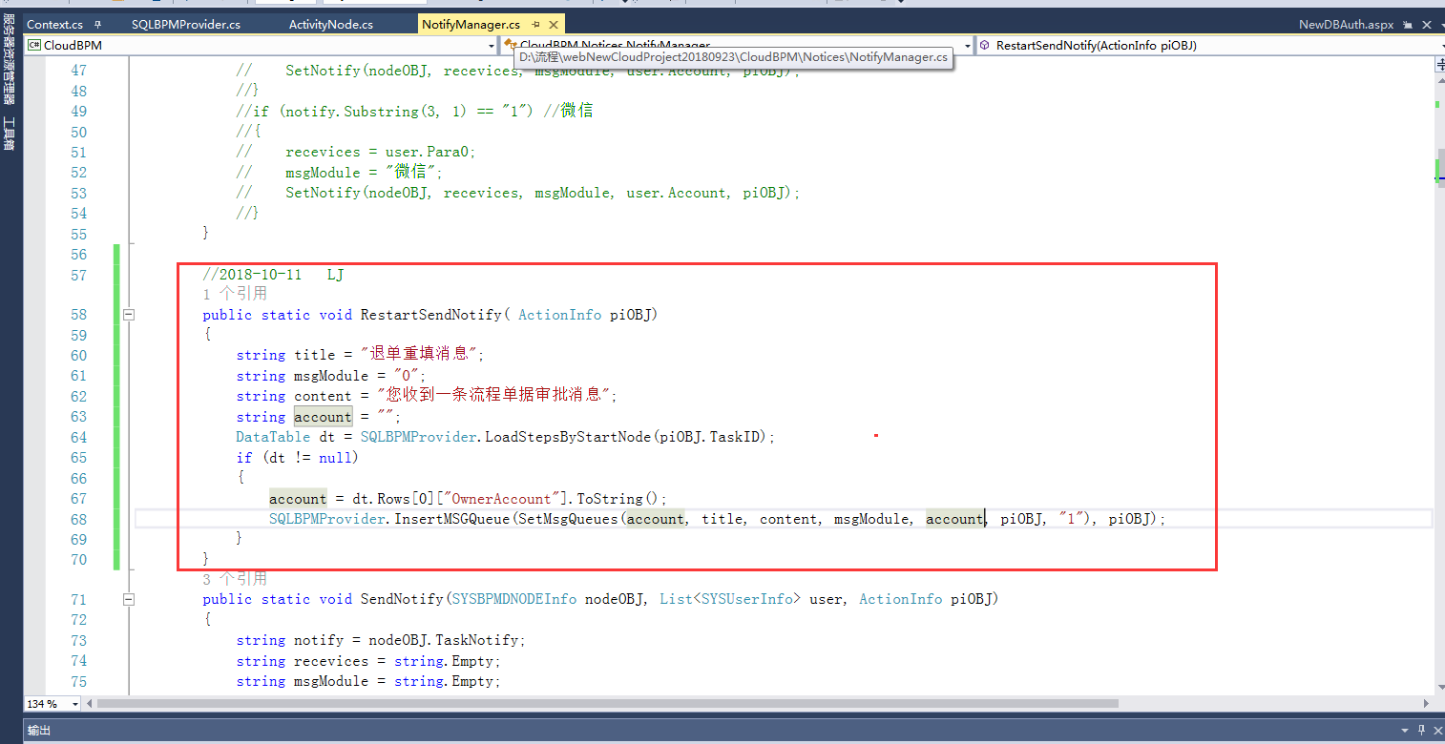

代码：

//2018-10-11 LJ

public static void RestartSendNotify( ActionInfo piOBJ)

{

string title = "退单重填消息";

string msgModule = "0";

string content = "您收到一条流程单据审批消息";

string account = "";

DataTable dt = SQLBPMProvider.LoadStepsByStartNode(piOBJ.TaskID);

if (dt != null)

{

account = dt.Rows[0]["OwnerAccount"].ToString();

SQLBPMProvider.InsertMSGQueue(SetMsgQueues(account, title, content, msgModule, account, piOBJ, "1"), piOBJ);

}

}

2、

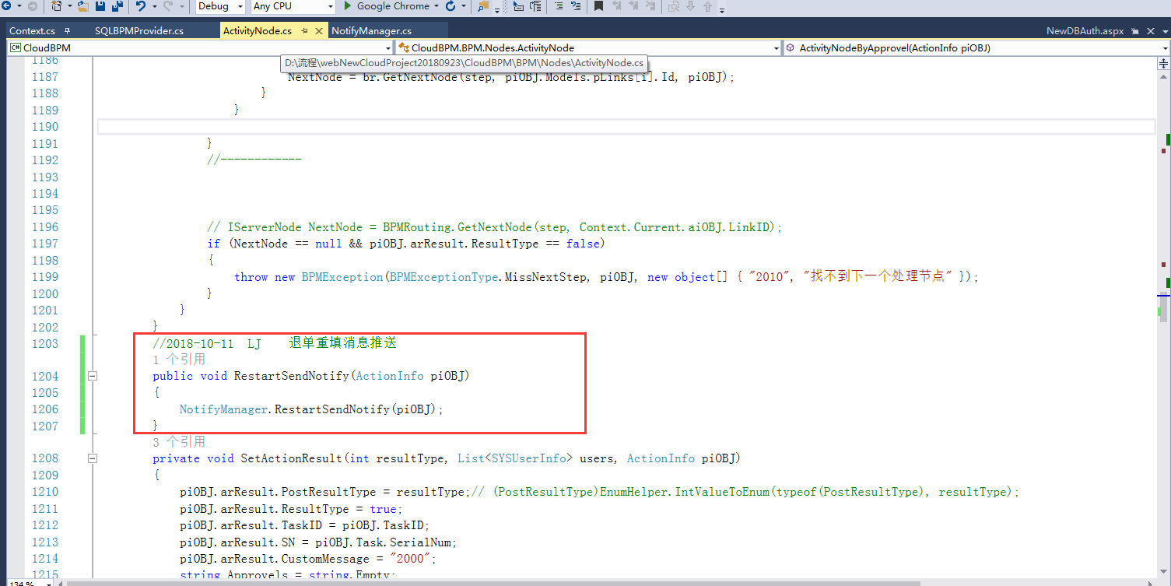

代码：

//2018-10-11 LJ 退单重填消息推送

public void RestartSendNotify(ActionInfo piOBJ)

{

NotifyManager.RestartSendNotify(piOBJ);

}

3、

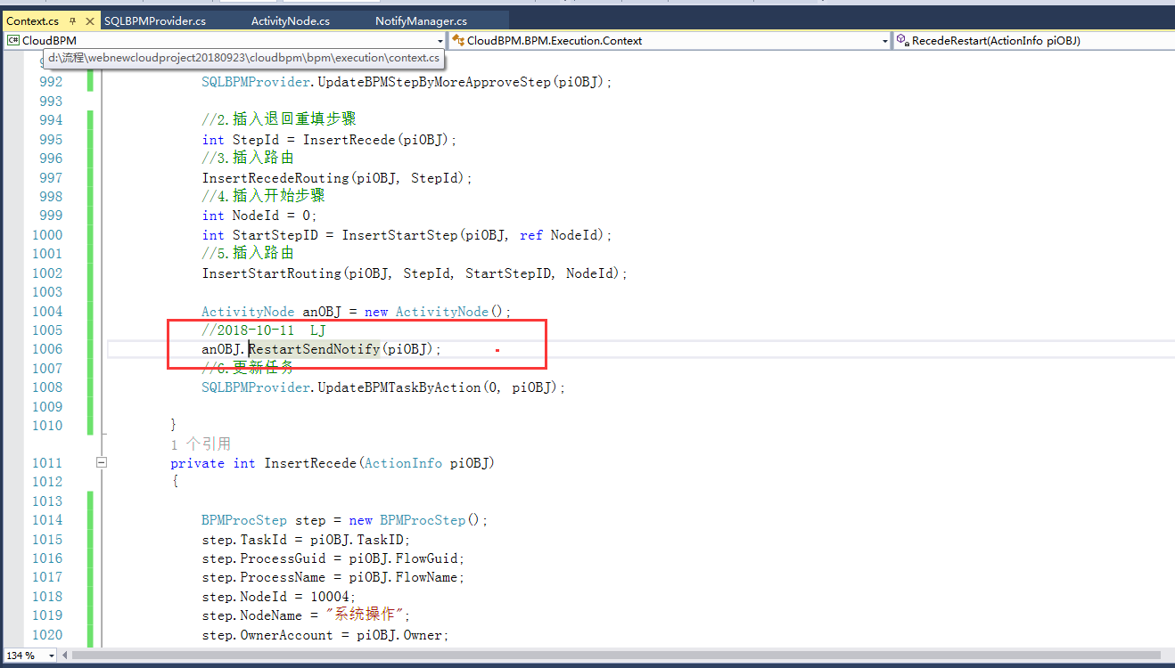

代码：

//2018-10-11 LJ

anOBJ.RestartSendNotify(piOBJ);